WHAT PONACKA PARENTS NEED TO KNOW 2023

July Campers  Prior to May 1 Submit forms  Saturday July 1 Departure for camp  Friday July 7 1 week departure  Friday July 14 1st 2-week camp ends  Saturday July 15 2nd 2-week camp begins  Thursday, July 27 Closing Ceremonies  Friday July 28 Departure from camp | August Campers  Prior to June 1 Submit forms  Wednesday August 2 Departure for camp  Tuesday August 8 1 week departure  Tuesday, August 15 1st 2-week camp ends  Wednesday August 16 2nd 2-week camp begins  Monday, August 28 Closing Ceremonies  Tuesday August 29 Departure from camp

Please mail forms in the enclosed return envelope. After May 1st, send to:
Camp Ponacka
376 Ponacka Rd.
Highland Grove ON K0L 2A0.

Otherwise, send via email to info@ponacka.com

It is really helpful if the payment (e-transfer or cheque) and forms can be sent at the same time.
Please do not send mail to the Selwyn address after May 20th.

For letters home, send your son with stamped, self-addressed envelopes. Please send e-mails to your son only if you live too far away for Canada Post regular service or are travelling.

Contact us anytime at info@ponacka.com

Contact information

May 20 - September 10 Don, Anne, Laura (705) 313-0758 or (705) 957-8258

September 10 - May 20 Don & Anne (705) 748-9470 or Laura (705) 957-9177

We do not call a camper to the telephone nor permit him to call home without exceptional reasons.

Summer Address | Camp Ponacka, 376 Ponacka Road, Highland Grove, ON K0L 2A0 (705) 313-0758 | 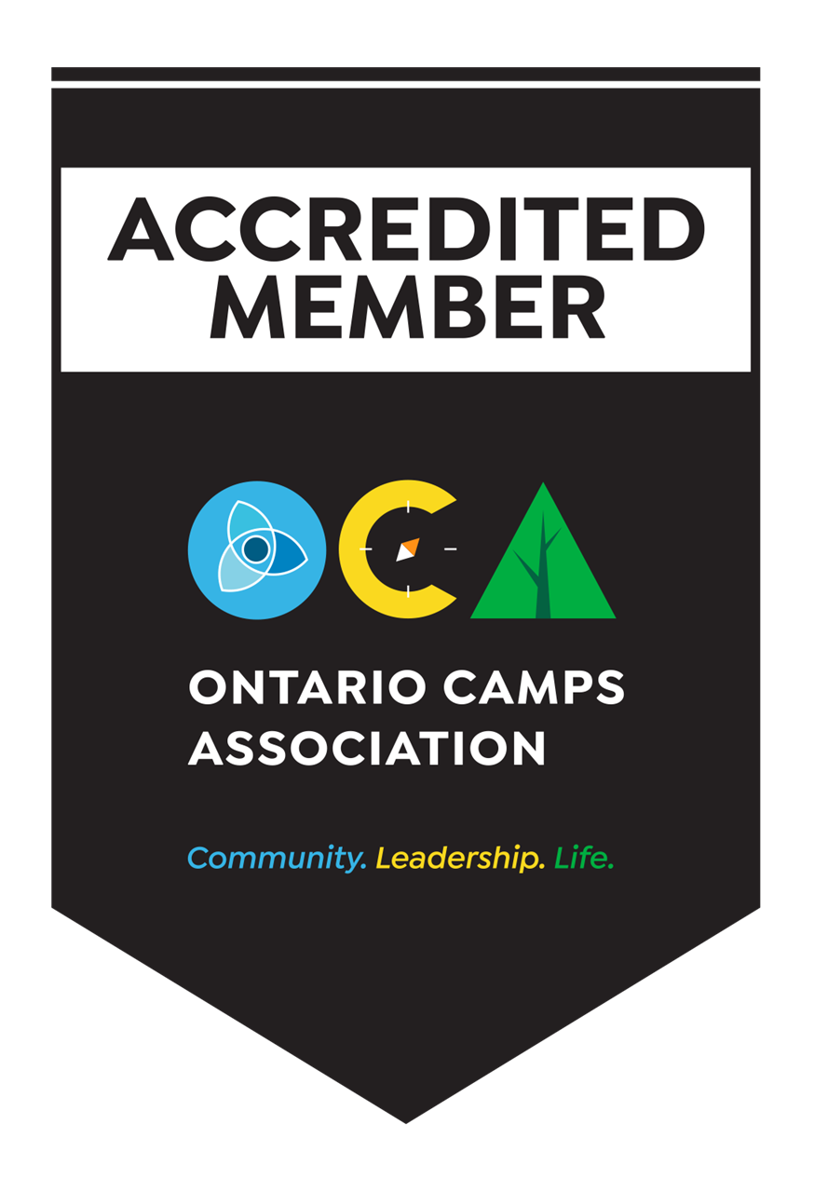

THE CAMP PROGRAM – Courses and Daily Sign-up

DAILY CHOICE PROGRAM

When not taking courses, campers choose from the following activities:

Aerial Rope Course (age 11+)
Archery
Basketball
Bushcraft
Canoeing
Climbing Wall (age 10+)

Crafts
Kayaking
Land Sports (hockey, volleyball, soccer)
Lapidary
Mountain Biking (age 12+)

Nature
Pottery
Sail Racing
Water Skiing
Windsurfing
Woodworking
Kayaking is available to boys in the oldest ten groups.
Windsurfing is available to boys in the oldest eight groups.
Rock Climbing Cookouts (age 11+)
Drama Production at the end of each month, all four-week boys are eligible to participate.

COURSE PROGRAM

Five activity periods are offered five days each week. Sunday is a special program day and Thursday is a cookout day.

Canoeing: Every camper takes a five-day course until he has earned his ORCKA Level 3. Your son may select additional lessons on the course enrolment sheet or sign up through the daily choice program.

Sailing: Sailing lessons are (** new for 2023) one-hour lessons for the beginner sailors and two hours long for the higher levels. A one-week course is recommended for a boy with no previous experience.

CANSail 1 and CANSail 2 require up to two weeks of sailing lessons, depending on previous experience. The keen sailor planning to earn CANSail 3 or 4 must enrol for 3 weeks. Sailing cookouts and 5th period racing provide more opportunities to sail.

Riding: We recommend 5 lessons for a camper who wishes to learn the basics. A camper who enjoys riding should be enrolled for 10 lessons. An experienced, keen rider can enrol for 15 lessons.

The extra charge is noted on the fee remittance form.

Swimming: see below

Swimming

The boys take 5 swimming lessons/week. There are optional “free swims” before lunch/dinner and before bed. Life Saving Society of Canada (LSSC) swim levels are offered. Please complete the swim section on the course enrollment sheet, using the chart below as a reference.

The Red Cross Learn to Swim program has ended. 2023 is our first summer offering the Lifesaving Society Learn to Swim Program. If unsure, our swim staff will assess your son’s swimming ability and place him in the correct class. Enclosing a copy of your son’s swim record is helpful.
Ponacka Swim Program

PREVIOUS SWIM LEVEL EARNED |  | 2023 SWIM LEVEL
Red Cross Swim Kids Levels 3-7 |  | Swimmer 3-7
LSSC ROOKIE PATROL |  | Swimmer 8/ Ranger Patrol
Red Cross Swim Kids 9 |  | Swimmer 9/ Star Patrol
LSSC RANGER PATROL |  | Swimmer 9/ Star Patrol
Red Cross Swim Kids Level 10 (highest award) |  | Bronze Star
LSSC STAR PATROL |  | Bronze Star
LSSC BRONZE STAR |  | Bronze Medallion
LSSC BRONZE MEDALLION & Emergency First Aid |  | Bronze Cross
LSSC BRONZE CROSS |  | Swim Instructor and Lifeguarding Instructor if age 15
STANDARD FIRST AID COURSE (16 hours) | Age 14+

FAMILY VISITING

We are planning for normal visiting weekends this summer on July 15 or 16 and August 19 or 20. Families are welcome to visit on either day. Last summer, we had no family visits and many parents indicated that they were content with having their boys enjoy a four week stay without a parental visit. We plan a special party for boys who have no parental visits during their stay.

There is no pressure on our part to plan a visit, it is entirely up to the parents and their sons to decide what best suits each family’s individual situation.

We strongly discourage visits for boys staying one or two weeks.

Plan to arrive at noon for your visit (no longer than 3 hours). We have Breakfast 8:30 -9:30am, Lunch 1-2 pm and Supper 6:30 -7:30pm. We hope that you will meet your son's counsellors and cabin mates.

Most parents bring a picnic lunch to enjoy with their son at one of our picnic tables around camp. Some parents take their son into Bancroft for lunch. We encourage you to bring bathing suits and swim at our beach. During such a swim, your family's safety is your responsibility.

For Sunday visits, plan to arrive by 10:30 am and join us for chapel. We encourage all boys to join in the Sunday afternoon program at 3 pm. Dogs on leashes are welcome!

AS YOU DEPART, please leave your son at an activity, at his cabin (if during rest period), or with his counsellor. Do not leave him in the parking lot, alone. Try to speak with Don, Anne, Laura or Graham during your visit - if you have any concerns, let them know. We strongly request that you leave NO food or drink behind.

CLOSING CEREMONIES

At the end of each month there is a Banquet, Awards Ceremony and Candlelight service in our chapel. Parents attending the banquet arrive no later than 5:30pm, for seating at 5:45 pm.

Parents not signed up for the banquet, are welcome to join us for the Awards Ceremony and Candlelight service at 7 pm. Usually only a few families will plan to attend. Most parents pick up their son the following morning.

If you are planning to take your son home that evening, please pack your car before dinner or during the break immediately following the Banquet. We encourage you to stay until the completion of the evening program (9pm). After bringing/picking up luggage at your son’s tent/cabin, please return your car to the parking lot.

Before you leave at the end of the chapel service, please come to the office so your son can receive his award envelope and RagBag newsletter and say good bye to us.

TRAVEL BY BUS

At the beginning and end of each month, chartered buses escorted by Ponacka staff, travel between Toronto and camp. There is no bus service in the middle of the month.

We recommend that first time campers travel to camp by bus, if convenient.

The buses load and unload at Toronto French School, 306 Lawrence Ave E, North York, ON

We provide fruit for the boys on the bus, please remember to fill his water bottle for the trip.

Plan to arrive no later than 1pm, as the buses WILL depart promptly at 1:30 pm

If you have any difficulty finding your son or the camp bus, call us immediately! 705 313-0758

BUS TRAVEL TO CAMP:
Saturday July 1 and Wednesday August 2
1:30pm departure from Toronto French School

BUS TRAVEL FROM CAMP:
Friday July 28 and Tuesday August 29
10 am departure from Ponacka to Toronto French School
Arrival in Toronto around 1:30pm (traffic dependent!)

The buses arriving back to Toronto may be early, so plan to arrive a bit early

TRAVEL BY CAR

ARRIVAL DAY: Plan to arrive at camp between 2-4 pm.

DEPARTURE DAY: Please pick up your son by noon. To avoid meeting our buses on the narrow roads, plan to arrive before 9:45 am or after 10:45 am.

ARRANGEMENTS FOR MEETING FLIGHTS

Ponacka staff will meet campers arriving at Pearson International Airport. If the flight arrives later than 11am, we will arrange to bring him directly to camp, rather than the camp bus. Please note the extra charge on the fee remittance form.

On departure day, flights must depart Toronto later than 5 pm. Our staff will make sure that your son is checked through customs and on his way.

If flying on a different date than the scheduled arrival and/or departure day, additional charges will apply.

HEALTH INFORMATION

* If your son has an illness or accident prior to his arrival, please contact us
* A health screening will be completed on arrival day
* Medication brought in a pill dispenser box makes administration easier for our medical staff
* If your boy is sensitive to mosquito bites, a tube of Benadryl cream will come in handy

* Remember to enclose a photocopy of both sides of your son's health card with the most recent version code

PARCELS and LETTERS

Food/candy are not to be sent or brought to camp. Please advise your relatives not to send food. We confiscate candy and Spitz which is upsetting for the boys. Racoons and chipmunks make unwelcome nocturnal visits to tents and cabins with food!

We are inundated with parcels resulting in more delivery trucks on our road and greater expectations on the part of the boys that they “need” packages from home. If your son needs an item of clothing or equipment, we are happy to expedite your package to him. Otherwise, we discourage sending parcels on a regular basis. A letter from home/extended family is a real treat in itself!

A short letter or postcard two or three times a week is encouraged – it is the “getting mail” that is important, not so much the letter length. Letters from home or extended family are greatly appreciated by the boys, even the older ones! Please do not write anything distressing in a letter. News of illness of family or close friends is upsetting and your son can do nothing about the situation except worry. Please call us if you have distressing news so that we can discuss the best way to inform your son.

We ask that you not send e-mails to your son unless you live too far away to access Canada Post delivery service.

ARRIVAL DAY BUNK LOTTERY FOR TENT GROUPS

Wishing to be fair to the boys who sleep in tents, we have a bunk lottery. Regardless of arrival time, a boy selects a random “top” or “bottom” bunk chit from his counsellor.

SPENDING MONEY

Pocket money needed for a trip away from camp is given to the camper from his tuck account. We ask boys not to bring money to camp. It is easily lost, upsetting for everyone.

SMOKING AND DRUGS

Campers are NOT allowed to possess or smoke tobacco products nor have non-medical drugs or alcohol at camp or on camping trips. If you think it appropriate, please warn your son that he will be expelled from camp for any violation of this ruling. NO FEE REFUND WILL BE MADE. We review the rules on the first night of camp with the older boys and offer an opportunity to get rid of any forbidden substances.

BOOKS, GAMES, COSTUMES
Our camp library and drama hut welcome donations!

TECHNOLOGY FREE

No cellphones, digital watches, iPods, computers, laser pointers, or e-readers are allowed at camp. No technology that has access to the internet is permitted.

Camp is a social place to enjoy the sounds of the natural world and create music with guitars, piano and instruments that staff and campers bring. Connecting with others is what camp is all about. These items will be confiscated and not returned. Phones belonging to international campers, used for travel to and from camp, will be safely stored until departure day.

Ordering Ponacka Clothing
New for 2023!

Click here to order online.

LABELLING BELONGINGS

Many articles of value are left at camp –most unlabeled! Labelled items are returned; however, we are still left with piles of unlabeled clothes, shoes, pillows, towels. Chances of items going missing are greatly reduced if well labelled. Please mail to us anything that erroneously goes home in the wrong trunk and we will forward the item. Expensive, brand name clothing is best left at home!

Please label shoes, paddles and lifejackets.

Get 15% off when your order through Mabel’s Labels. Use the code CAMP2023 or the link below:

camps.mabelslabels.com

EQUIPMENT

- Rain gear, waterproof stuff sack and compact sleeping bag are essential for four-week campers
- Aqua socks are excellent for water-based activities.
- A labelled Swiss army type of knife is permitted. Your son must demonstrate responsible use.
- Some boys bring mouth guards to use when playing road hockey
- Helmets will be provided to boys who mountain bike, climb and ride horses.
  - Ponacka baseball caps may be purchased at the tuck shop.

FOOTWEAR

Due to the high incidence of stubbed toes, rolled ankles and heel blisters caused by open toed “slides”, we are asking that you send your son with closed toed footwear like keen sandals or running shoes. The combination of rugged terrain and the proclivity of boys to run everywhere makes appropriate footwear important to prevent injuries. Crocs are fine for trips to the waterfront but stable, comfortable shoes should be worn the rest of the day.

WASTE DISPOSAL

At Ponacka, we use outhouses (kybos). This system does not require gallons of water nor the clearing of acres of forest for a larger septic system. The outhouses are cleaned daily, yet an odour is almost unavoidable. We think your son will understand if you discuss this with him. We compost and recycle.

PHILANTHROPY at PONACKA

Since Ponacka’s inception, campers and staff have been asked if they wish to donate a small amount from their tuck account for charity,

Over the years, we have supported the Bancroft Hospital, Pueblito, Kinark Kids in Camp, Friends of Honduran Children and Ponacka Ghana, Our Children Africa.

You may notice this charge on your son’s tuck account. If you have any questions, please let us know.

Each summer, Ponacka Alumni supports boys, selected from Big Brothers & Sisters in Peterborough, to attend Ponacka. In 2022, we had three boys attend camp, thanks to the generosity of former Ponackians.

The alumni charity, “Suns of Sphairee” is named after our popular mini tennis game at camp, called “pickleball” by the rest of the world!

